Create a Thread by extending the Thread class

Create a Thread by Implements the Runnable Interface.

Create a Thread by extending Thread class set and get the name of thread.

Create a Thread by extending Thread class set and get the priority of thread.

Create a Thread by extending Thread class apply Yield Method.

Create a Thread by extending Thread class apply join Method

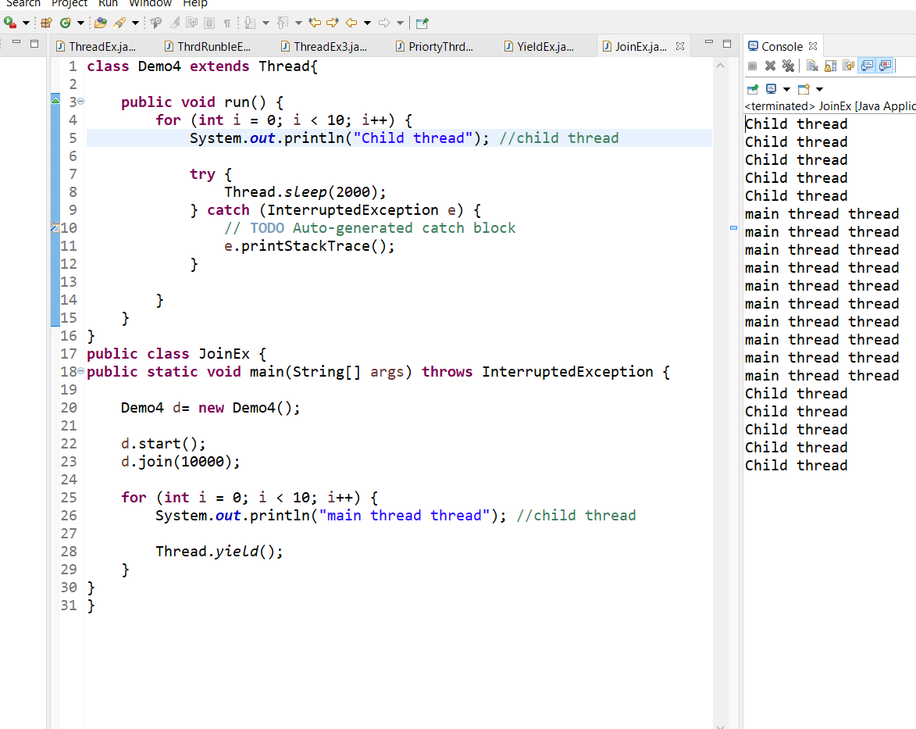

Create a Thread by extending Thread class apply sleep Method.

Create a Deadlock class to demonstrate deadlock in multithreading environment

Implement wait, notify and notifyAll methods.Create a Account class with methods withdraw, deposit, enquiry, add with synchronized keywords observe the output.



